MODULE END ASSIGNMENT
Logistics & Transportation: Fleet Performance & Delivery Efficiency
Tool Used: Power BI Desktop
Project Title | Fleet Performance & Delivery Efficiency Dashboard
Tool | Microsoft Power BI Desktop
Dataset | Logistics Dataset — Trip_Data (50 rows) + Vehicle_Master (7 vehicles)

1. Data Cleaning & Modeling

1.1 Power Query — Cleaning Steps
The raw dataset was loaded into Power BI using Get Data → Excel Workbook. Both sheets were opened in Power Query Editor for cleaning.
- Removed garbage rows (portfolio text accidentally included in dataset)
- Deleted 'Projects' column — contained irrelevant text
- Fixed Distance_km error — replaced '116+666' using Replace Errors → 0
- Changed Delivery_Date type to Date — converted Excel serial numbers to proper dates
- Applied Steps verified: Source → Navigation → Promoted Headers → Changed Type → Removed Columns → Filtered Rows → Replaced Errors

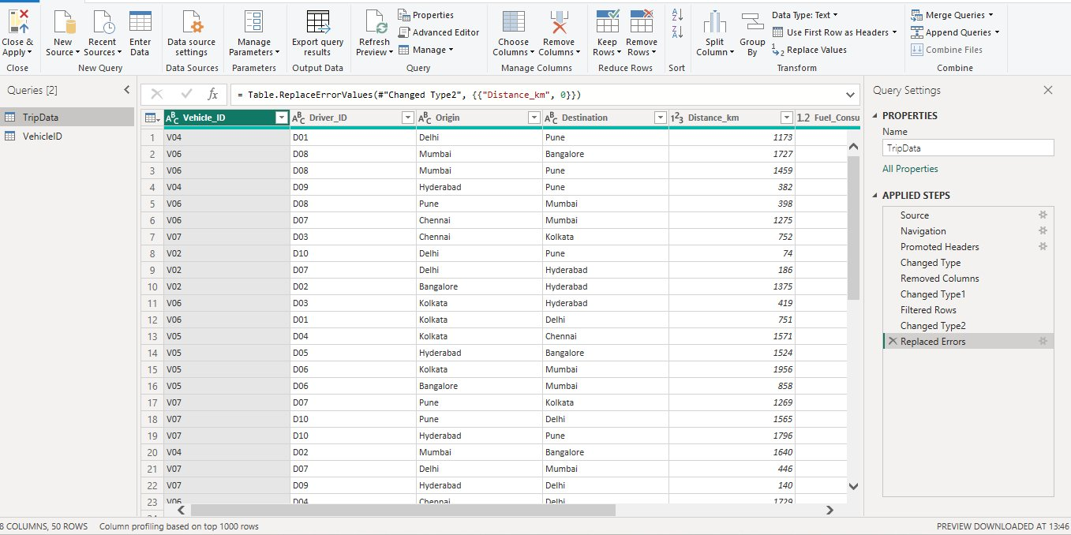
Screenshot 1: Power Query Editor — Applied Steps & Cleaned Data (50 rows, 8 columns)

1.2 Data Modeling — Relationship
Relationship created between TripData[Vehicle_ID] and VehicleID[Vehicle_ID] with Many-to-One cardinality.
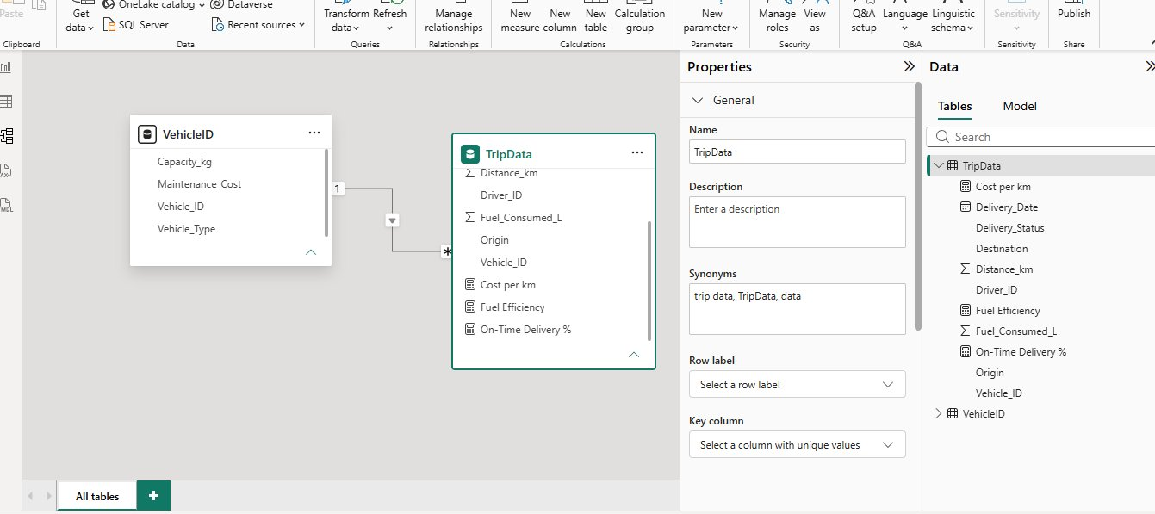
Screenshot 2: Model View — TripData and VehicleID tables connected via Vehicle_ID

2. DAX Measures
Three DAX measures were created under TripData table:

Measure | DAX Formula | Result
Fuel Efficiency | DIVIDE(SUM(TripData[Distance_km]), SUM(TripData[Fuel_Consumed_L])) | 11 km/litre
On-Time Delivery % | DIVIDE(COUNTROWS(FILTER(TripData, TripData[Delivery_Status]="On-Time")), COUNTROWS(TripData)) * 100 | 60%
Cost per km | DIVIDE(SUMX(TripData, RELATED(VehicleID[Maintenance_Cost])), SUM(TripData[Distance_km])) | 10 INR/km

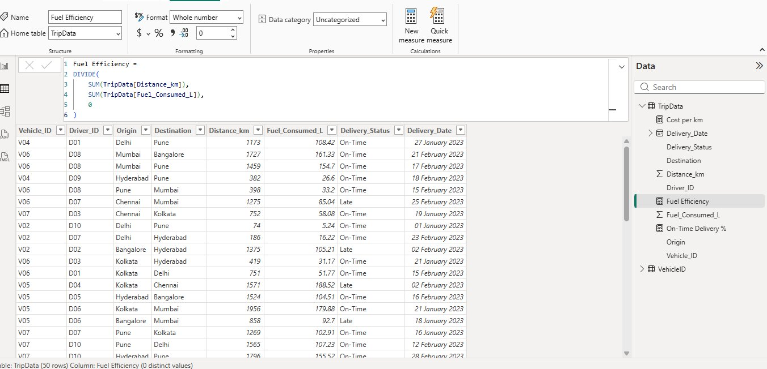
Screenshot 3: Fuel Efficiency DAX Measure
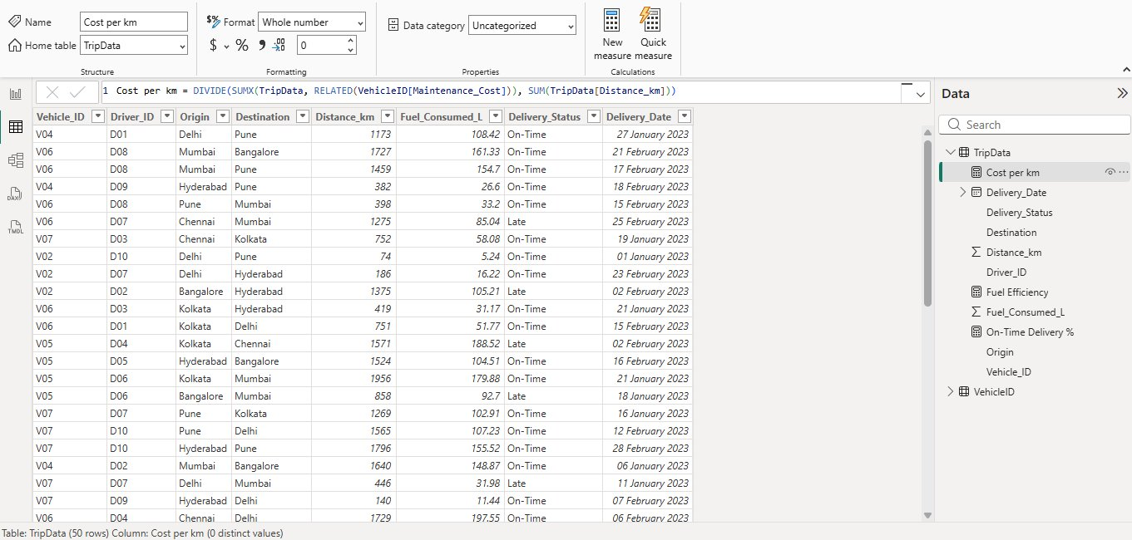
Screenshot 4: Cost per km DAX Measure
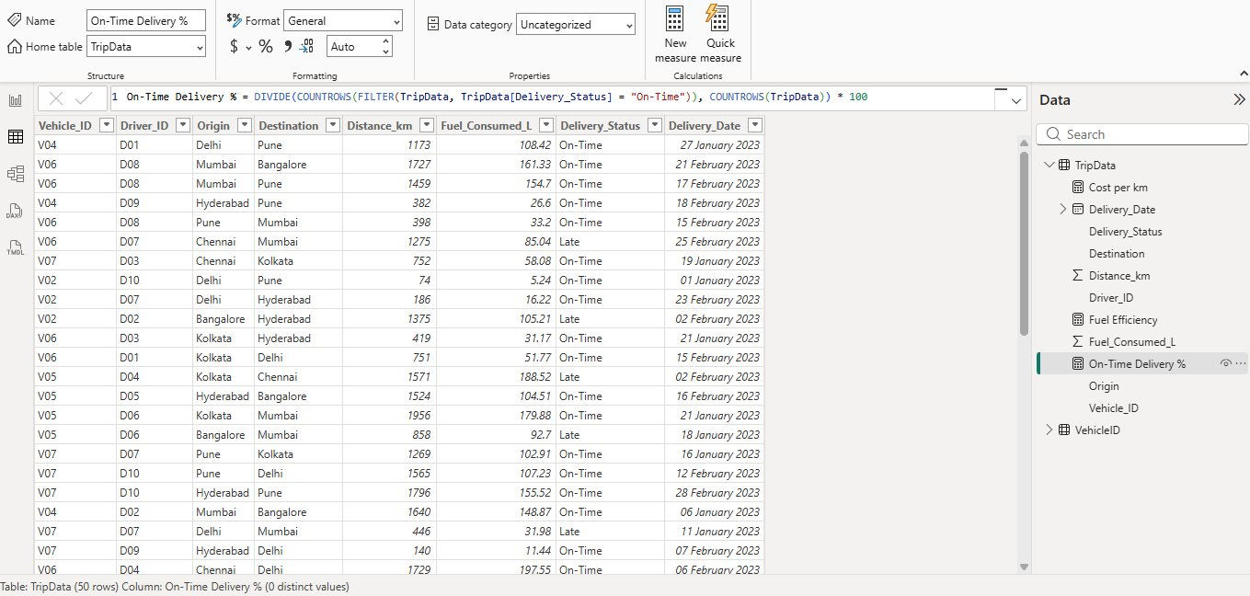
Screenshot 5: On-Time Delivery % DAX Measure

3. Visualizations

3.1 Final Dashboard
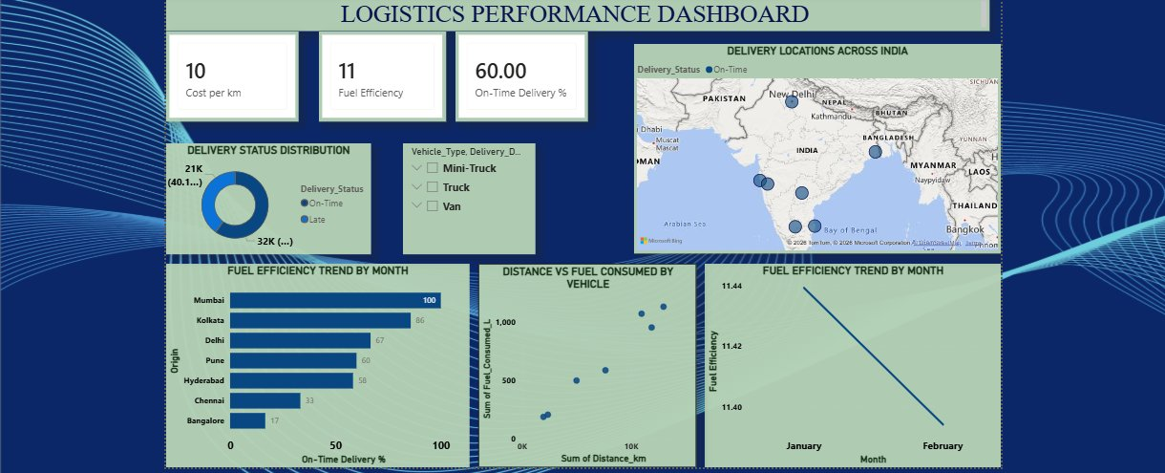
Screenshot 6: Final Logistics Performance Dashboard

Visual | Type | Insight
On-Time Delivery % by Origin | Bar Chart | Mumbai 100% (best) | Bangalore 17% (worst)
Fuel Efficiency by Month | Line Chart | Slight decline from Jan (11.44) to Feb (11.40)
KPI Cards | Card Visual x3 | Cost=10 | Fuel Efficiency=11 | On-Time=60%
Delivery Locations | Map Visual | Delivery hotspots across India — Delhi, Mumbai, Kolkata, Chennai, Hyderabad, Bangalore

4. Conclusion
The Logistics Performance Dashboard successfully analyzes fleet performance across on-time deliveries, fuel efficiency, and cost per km. Key findings:
- Mumbai routes — 100% on-time delivery (best performing)
- Bangalore routes — only 17% on-time delivery (needs improvement)
- Fleet average fuel efficiency — 11 km/litre
- Cost per km — 10 INR/km; Heavy Trucks have highest maintenance cost
- Map visual shows delivery concentration across 6 major Indian cities

The dashboard enables data-driven decisions to optimize routes, reduce costs, and improve delivery performance across the fleet.

